|  |
| --- |
| (Travel Kings Inc.) |
| Assignment 3 |
| **Group 2** |
|  |
|  |
|  |

|  |
| --- |
| Created By: **Group 2** |
| Person 1: Khai Phan |
| Person 2: Zain Ali |
| Person 3: Adrian Recchi |
| Person 4: Luqman Dewji |

**Table of Contents**

**1 Business Description 3**

**2 Information System Project Proposal 3**

**3 Stakeholder Analysis of the Information System Project 3**

**4 Business Processes (B****.P)** 3

4.1 Search for price deals on departure/arrival dates by Khai Phan 3

4.2 Make changes on Flight ticket by Khai Phan 4

4.3 Contact Customer Support by Zain Ali 4

4.4 Select popular vacation packages based on travel dates by Zain Ali 4

4.5 Compare prices among different hotel services by Adrian Recchi 5

4.6 Compare different prices between rental vehicles by Adrian Recchi 5

4.7 Sign up for membership account by Luqman Dewji 5

4.8 Provide recommendation based on price and popularity by Luqman Dewji

**5 System Use Case Diagram(s) 7**

**6 System Use Case Specifications**  8

6.1 Search Flight on selected dates 8

6.2 Make changes on Flight ticket

6.3 Contact Customer Support

6.4 Select Popular Vacation Packages

6.5 System Use Case Name

6.6 System Use Case Name

6.7 Sign up for membership

6.8 Provide recommendation based on price and popularity

**7 Non-Functional requirements** 9

# **Business Description**

* We are looking to open a business that offers cheap flight tickets, hotel deals, car rental and especially low-cost travel bundle (included flight ticket, hotel, and car rental). Our website will play a role as a third party website for customers who are looking to travel without having to search any further

# **Information System Project Proposal**

* In our website, customers can search between thousands up to million deals around the world for cheap flight, hotel insider deals, cheap car rental package and even more with the combination of everything. What we will do is we will get the database from all the flights, hotel deals around the world and then from the set price on the database, we will add in our profit to make sure our price always be cheaper than what you get from their airlines or any travel agency (maybe not online).

# Business Processes (Two business processes per student)

First, list all the potential business processes that your system is able to support here.

Then, each student chooses two business processes to work on the details as instructed below.

All business processes:

1. Search for price deals on departure/arrival dates
2. Make changes on the Flight ticket.
3. Contact customer support
4. Select Popular vacation packages according to travel dates
5. Compare prices among different hotel services
6. Compare different prices between rental vehicles
7. Sign up for membership accounts.
8. Provide recommendations based on price and popularity

# **Stakeholder Analysis of the Information System Project**

|  |  |  |  |
| --- | --- | --- | --- |
| **Stakeholder** | **Role** | **Power** | **Interest** |
| Customer | User | High | Low |
| Investors | Decision Maker | High | Medium |
| Company President | Decision Maker | High | High |
| Marketing Manager | Decision Maker | Medium | High |
| Marketing Employee | Developer | Low | Medium |
| Travel Advisor Manager | Decision Maker | Medium | High |
| Travel Advisor Employee | Developer | Low | Medium |
| Customer Service Manager | Decision Maker | Medium | High |
| Customer Service Employee | Developer | Low | Low |
| Accounts Receivable Manager | Decision Maker | Medium | High |
| Accounts Receivable Employee | Developer | Low | Low |
| Programmer | Developer | Low | High |
| System Analyst | Legislator | Medium | High |

## **Business Process 1:** Search for price deals on departure/arrival dates **by** Khai Phan

### **To-Be Process**

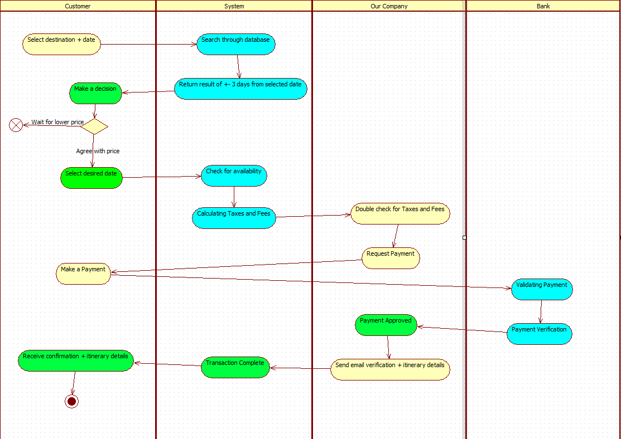

### **Context Diagram for To-Be Process**

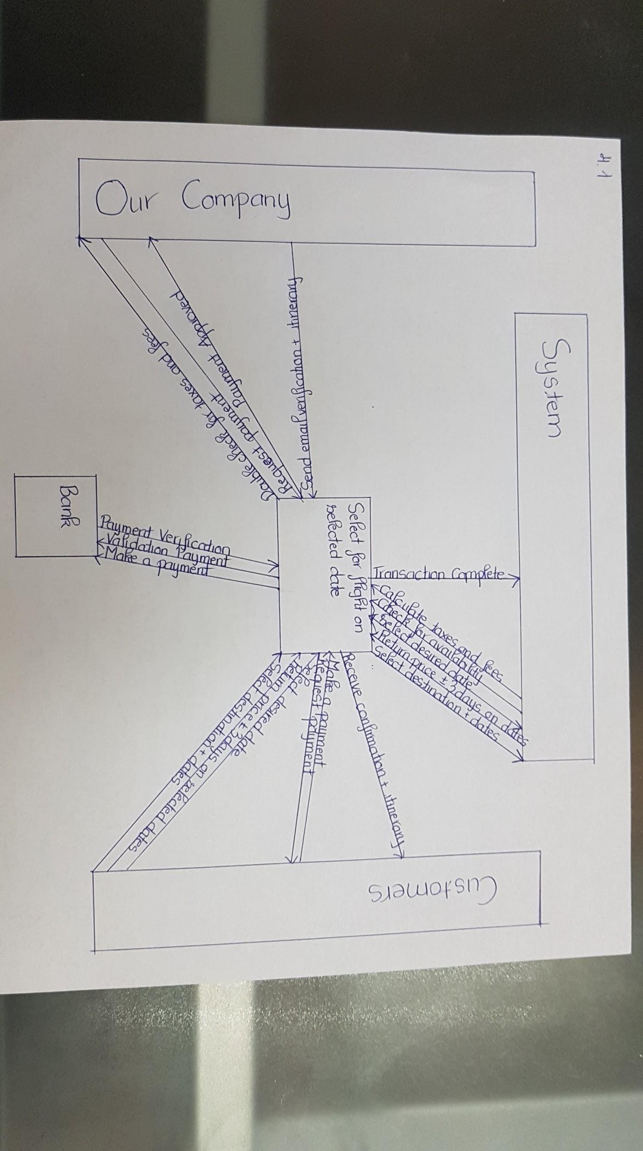

## **Business Process** 2**:** Make changes on Flight Ticket **by** Khai Phan

### **To-Be Process**

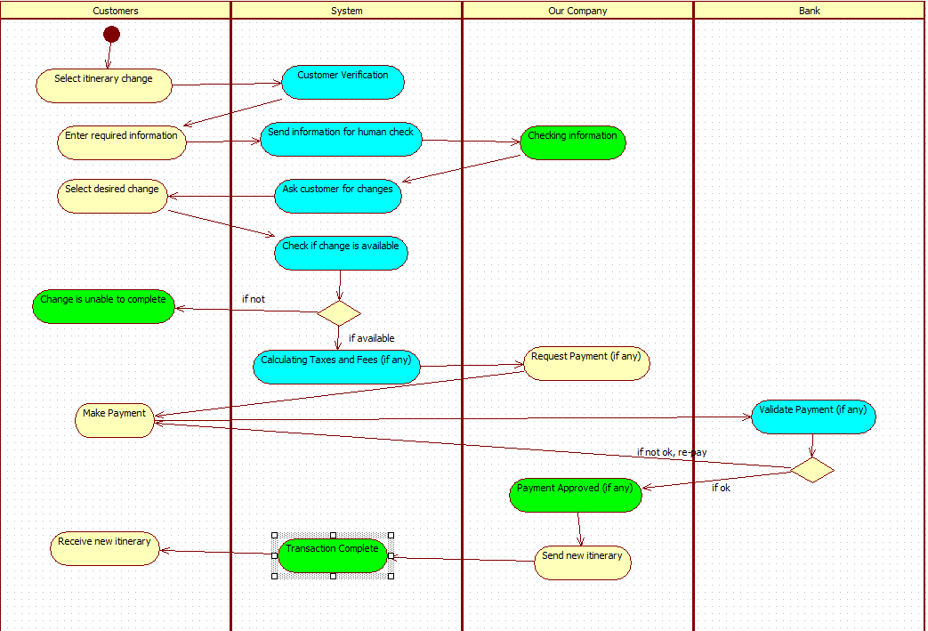

### **Context Diagram for To-Be Process**

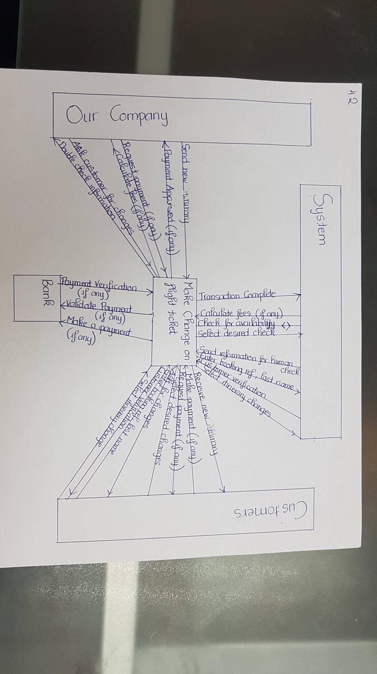

## **Business Process** 3**:** Contact Customer Support **by** Zain Ali

### **To-Be Process**

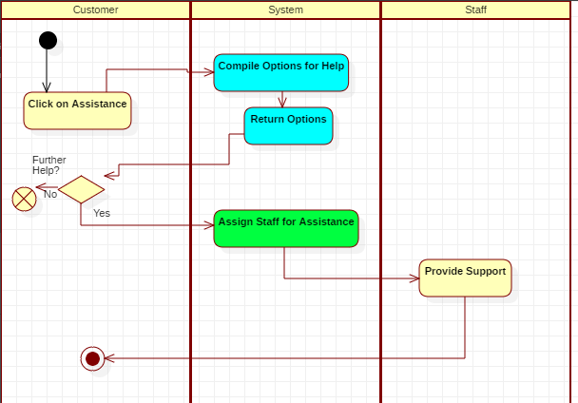

### **Context Diagram for To-Be Process**

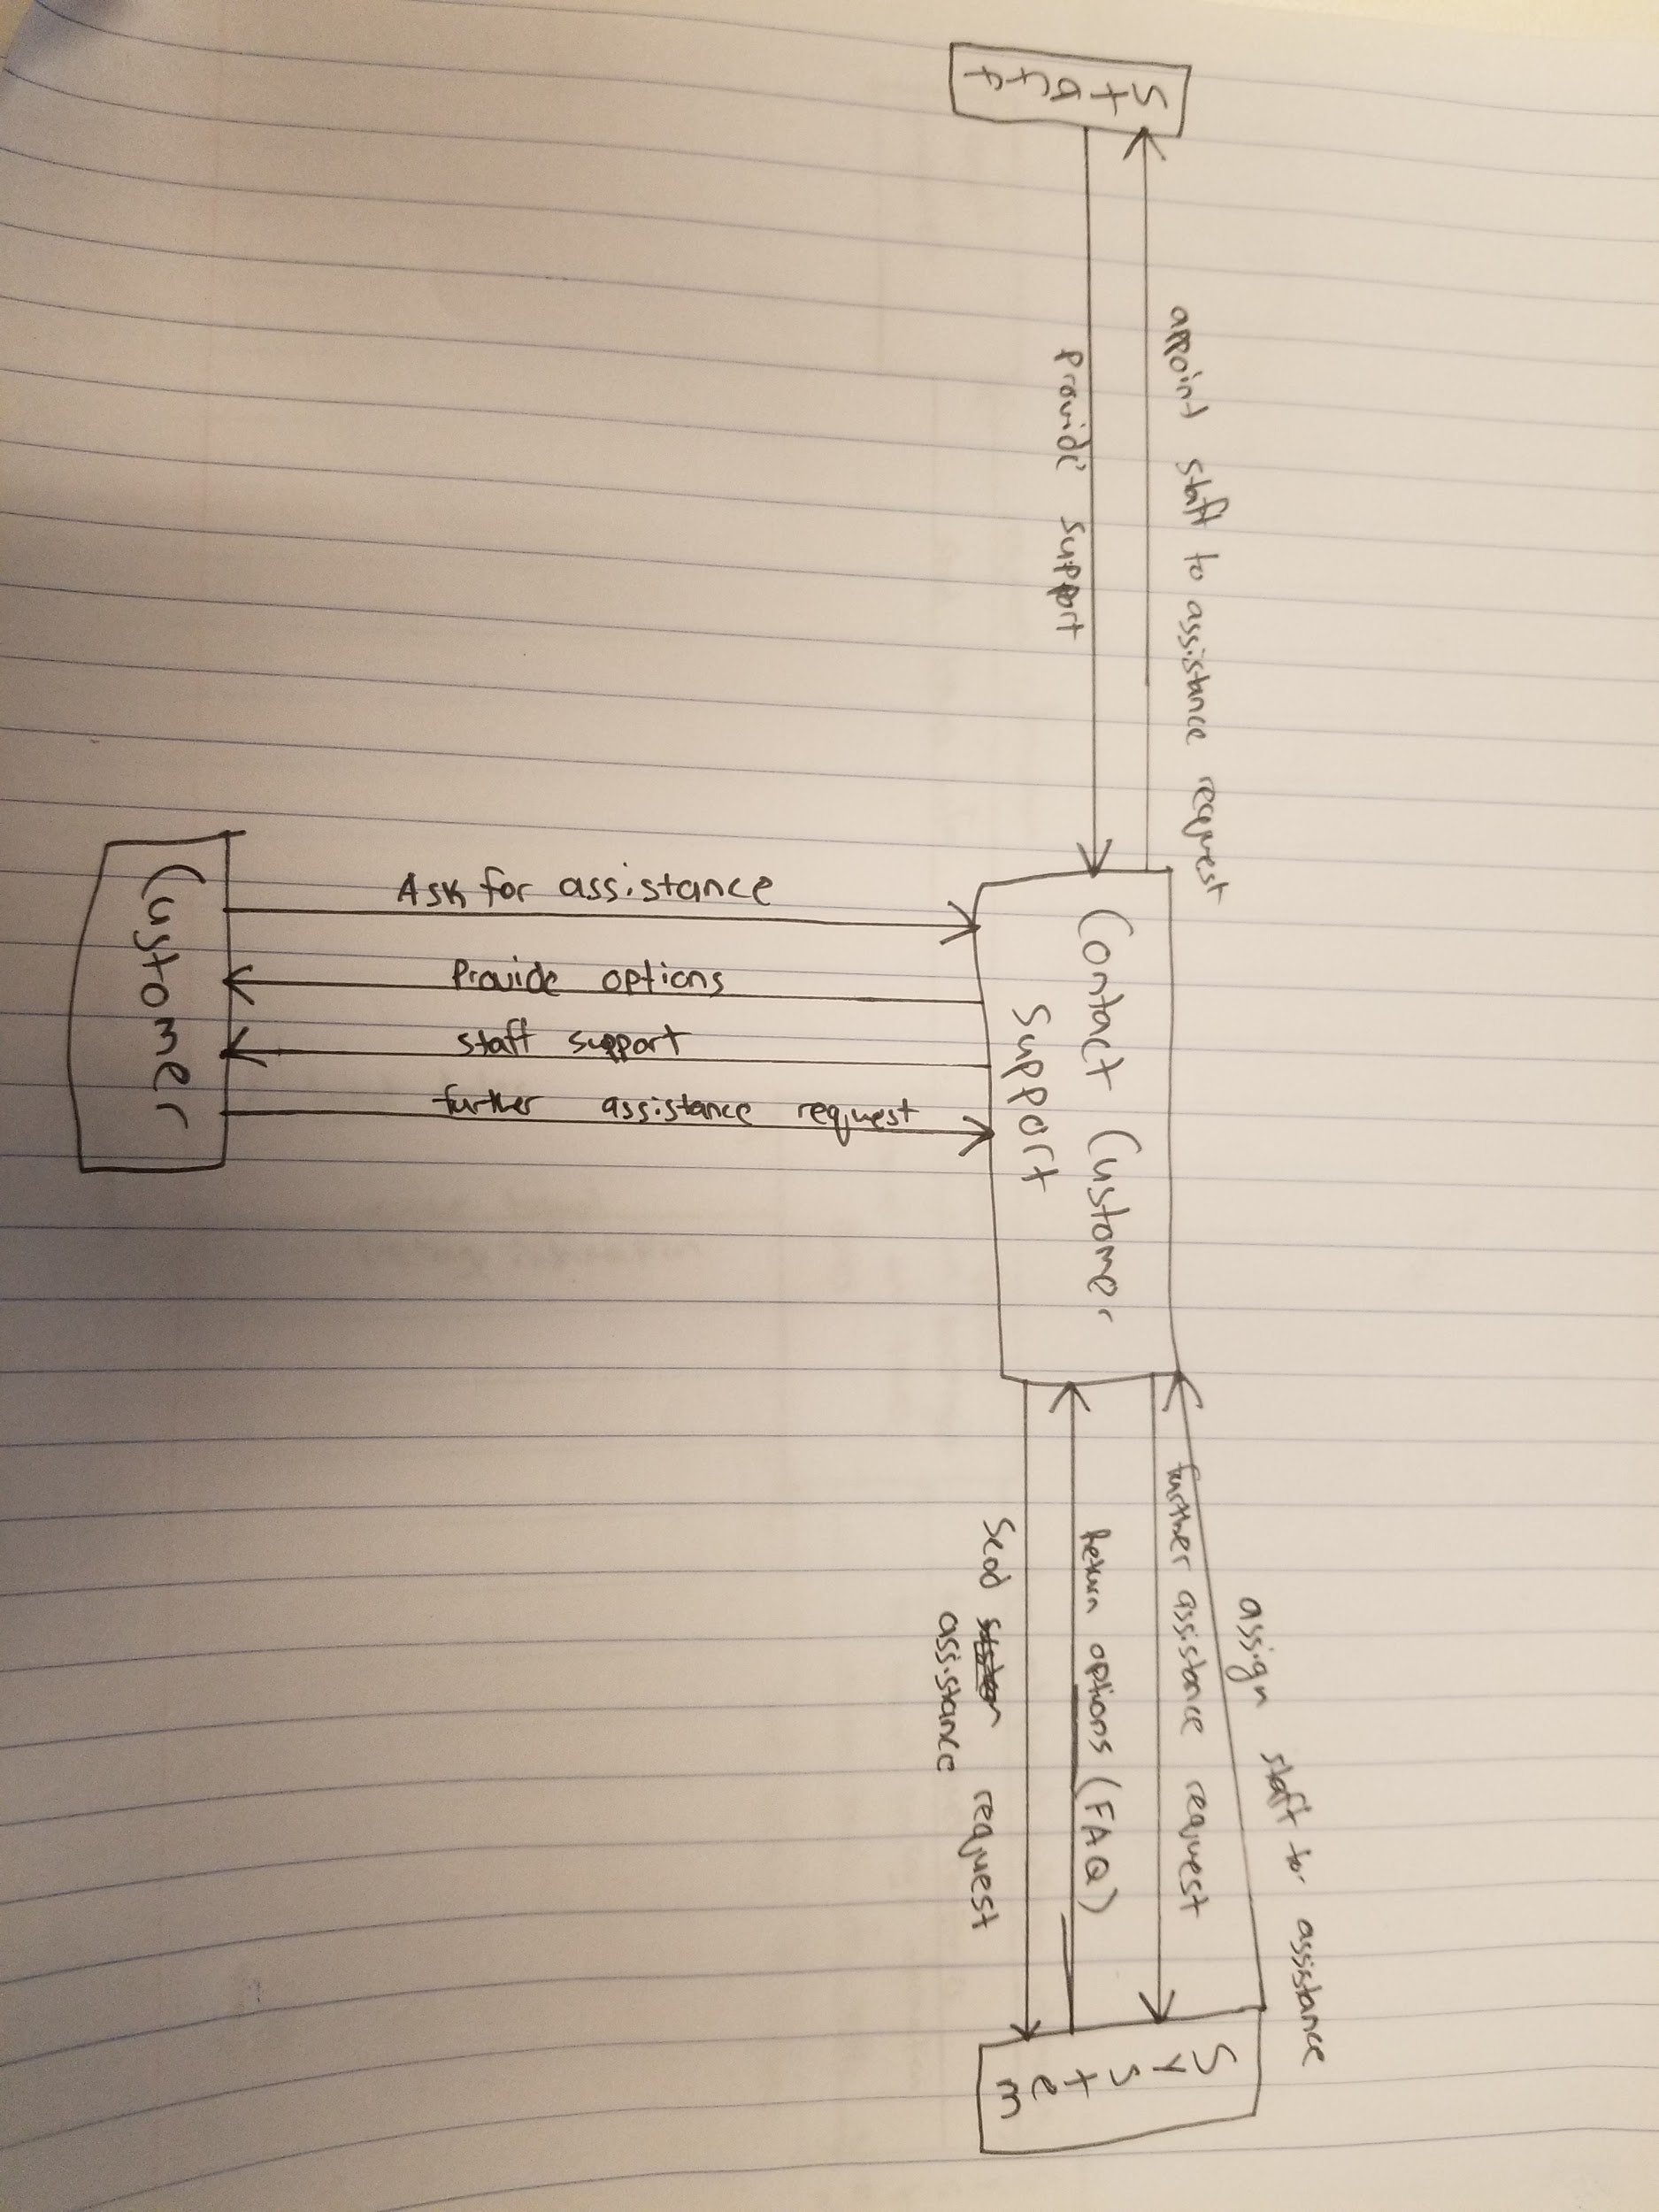

## **Business Process** 4**:** Select popular vacation packages based on travel dates **by** Zain Ali

### **To-Be Process**

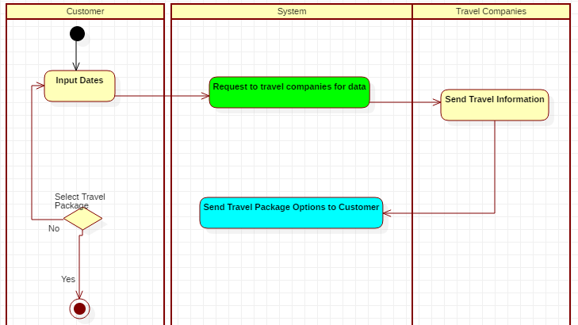

### **Context Diagram for To-Be Process**

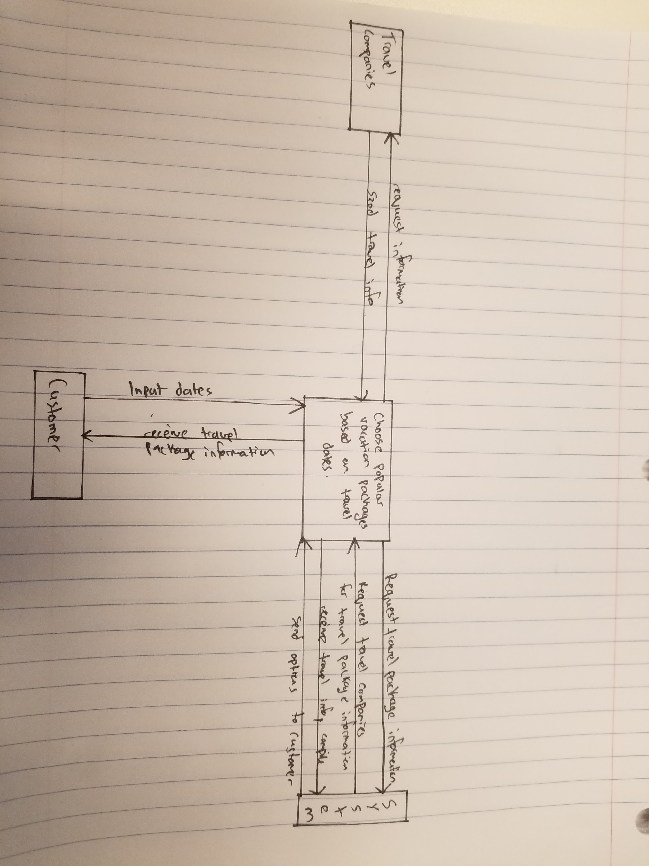

## **Business Process** 5**:** Compare prices among different hotel services by Adrian Recchi

### **To-Be Process**

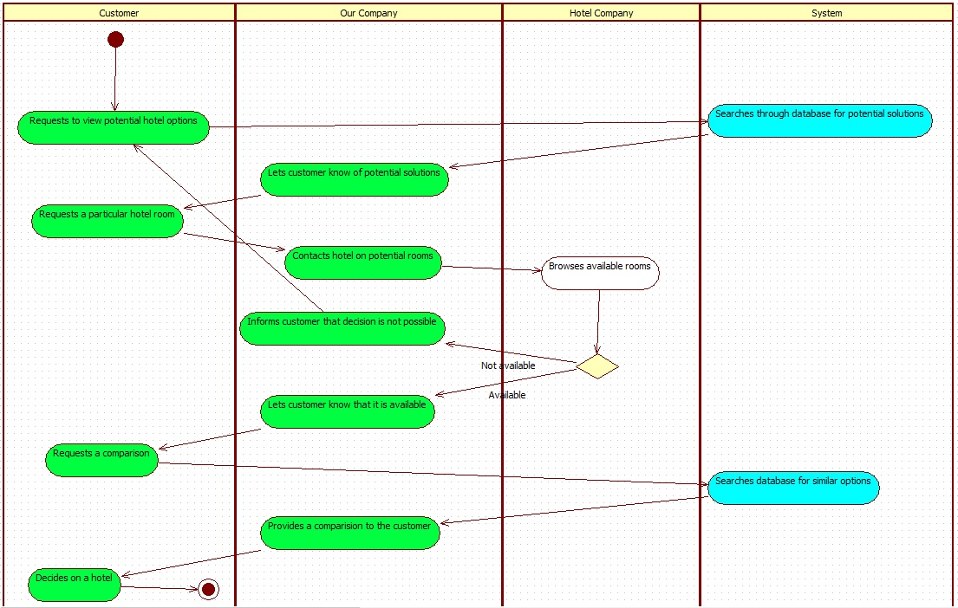

### **Context Diagram for To-Be Process**

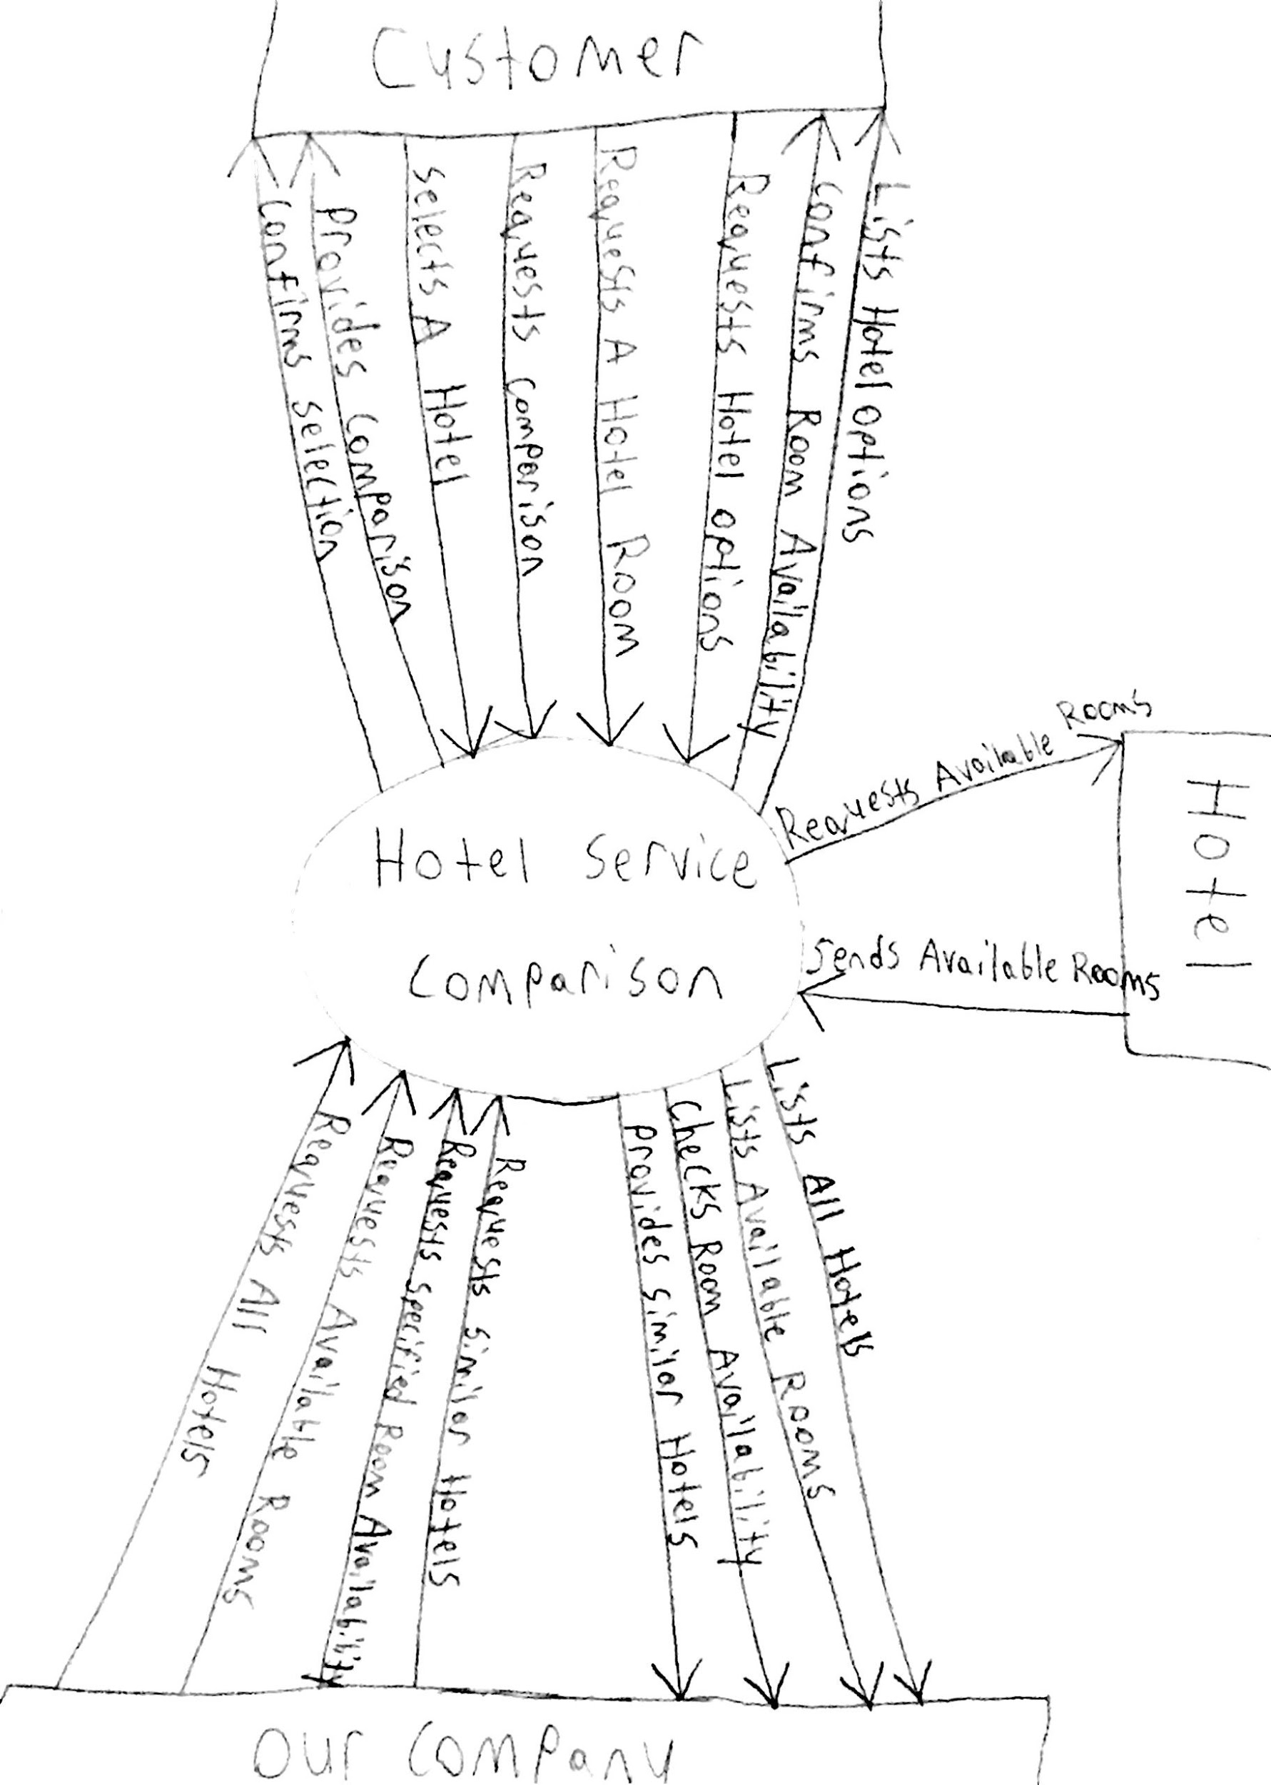

## **Business Process** 6**:** Compare different prices between rental vehicles by Adrian Recchi

### **To-Be Process**

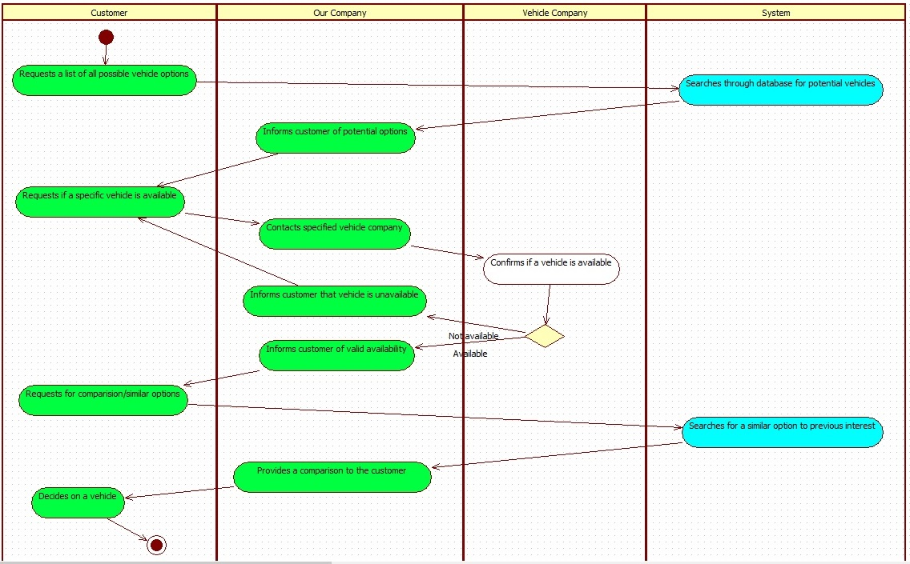

### **Context Diagram for To-Be Process**

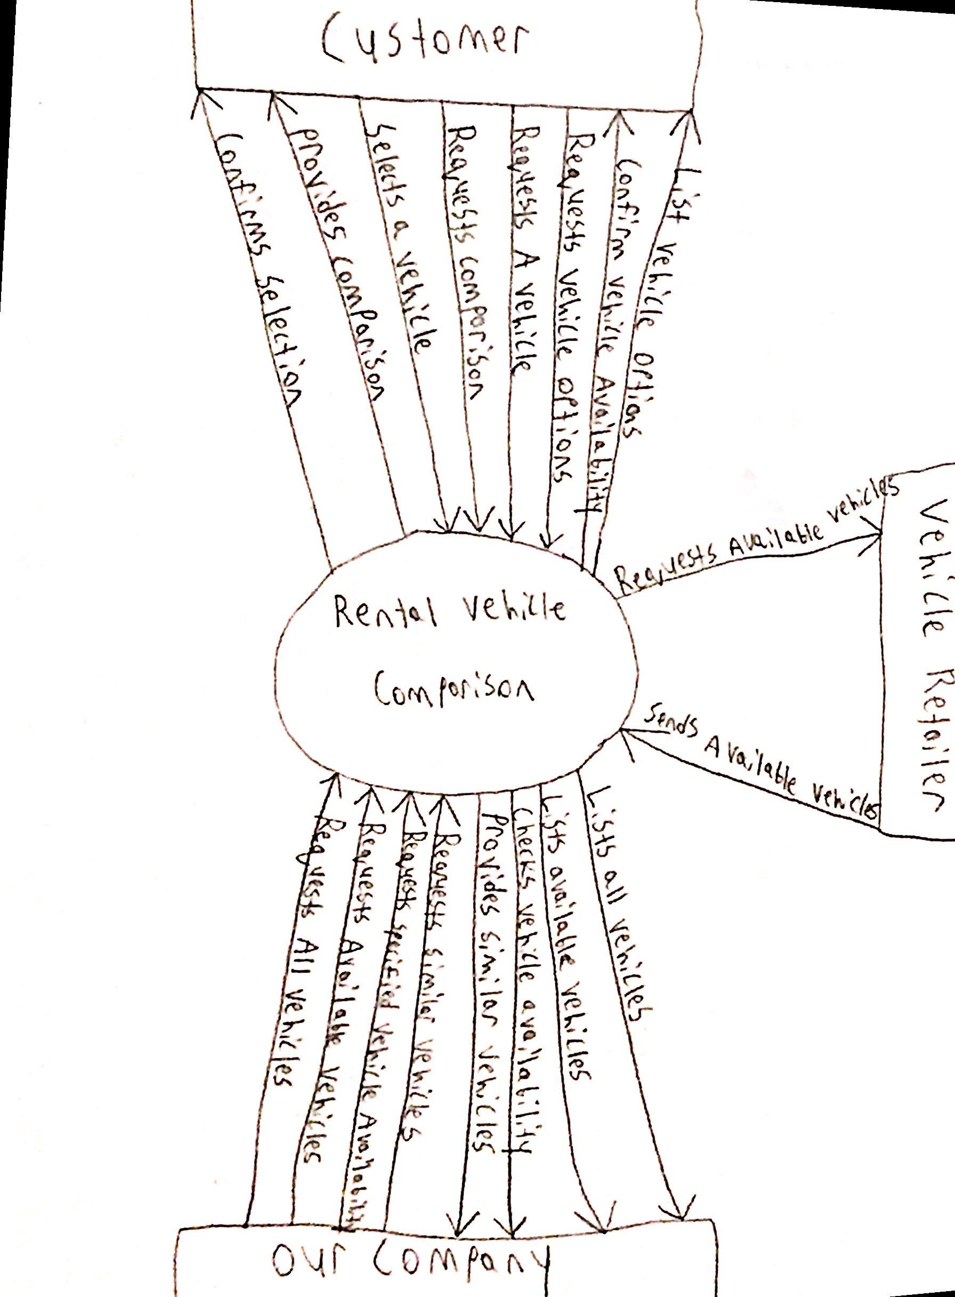

## **Business Process** 7**:** Sign up for membership **by** Luqman Dewji

### **To-Be Process**

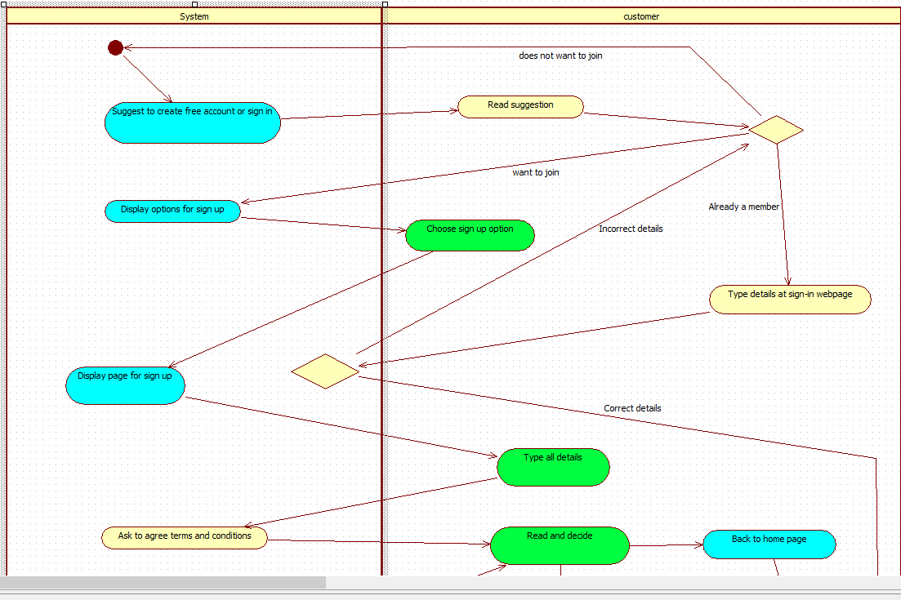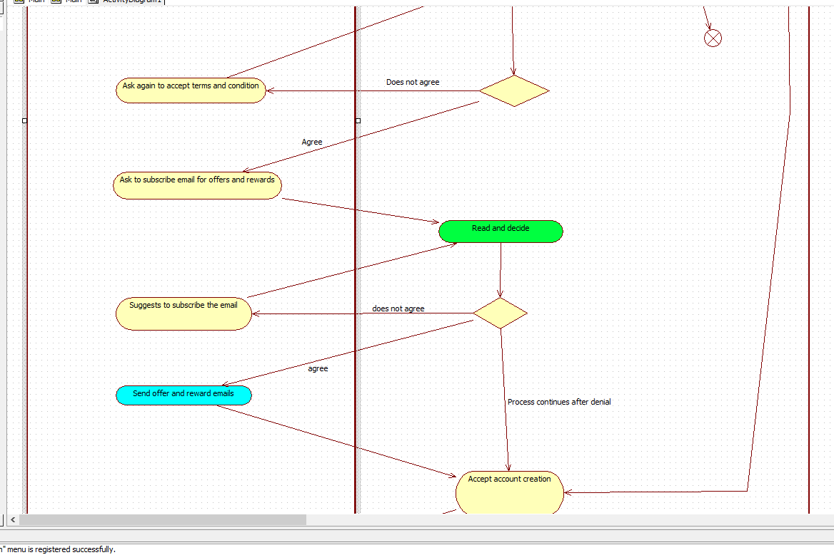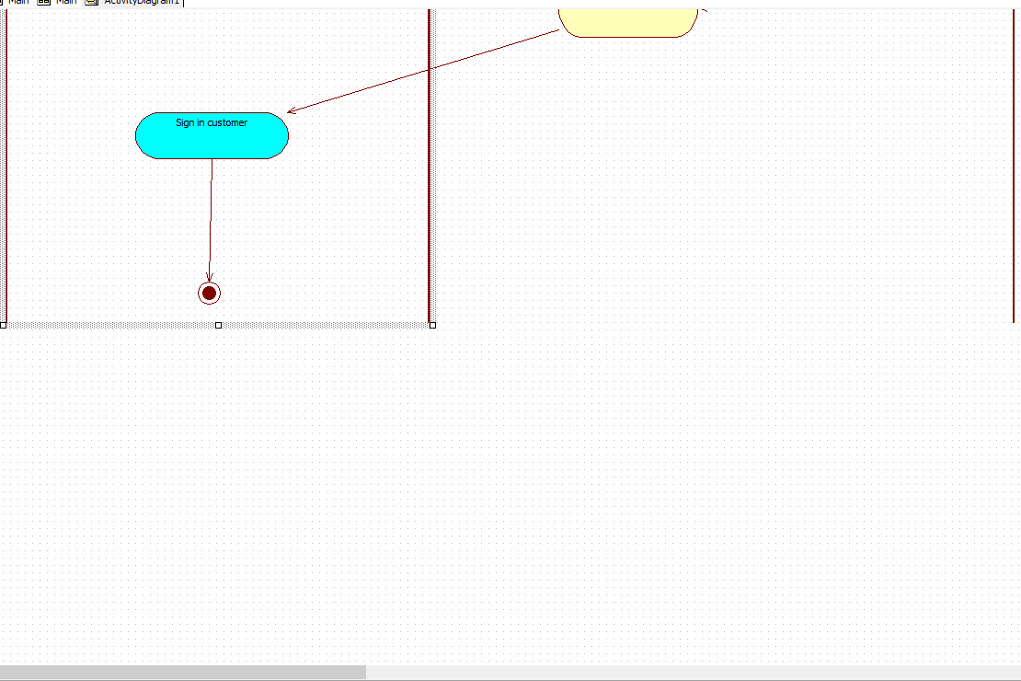

### **Context Diagram for To-Be Process**

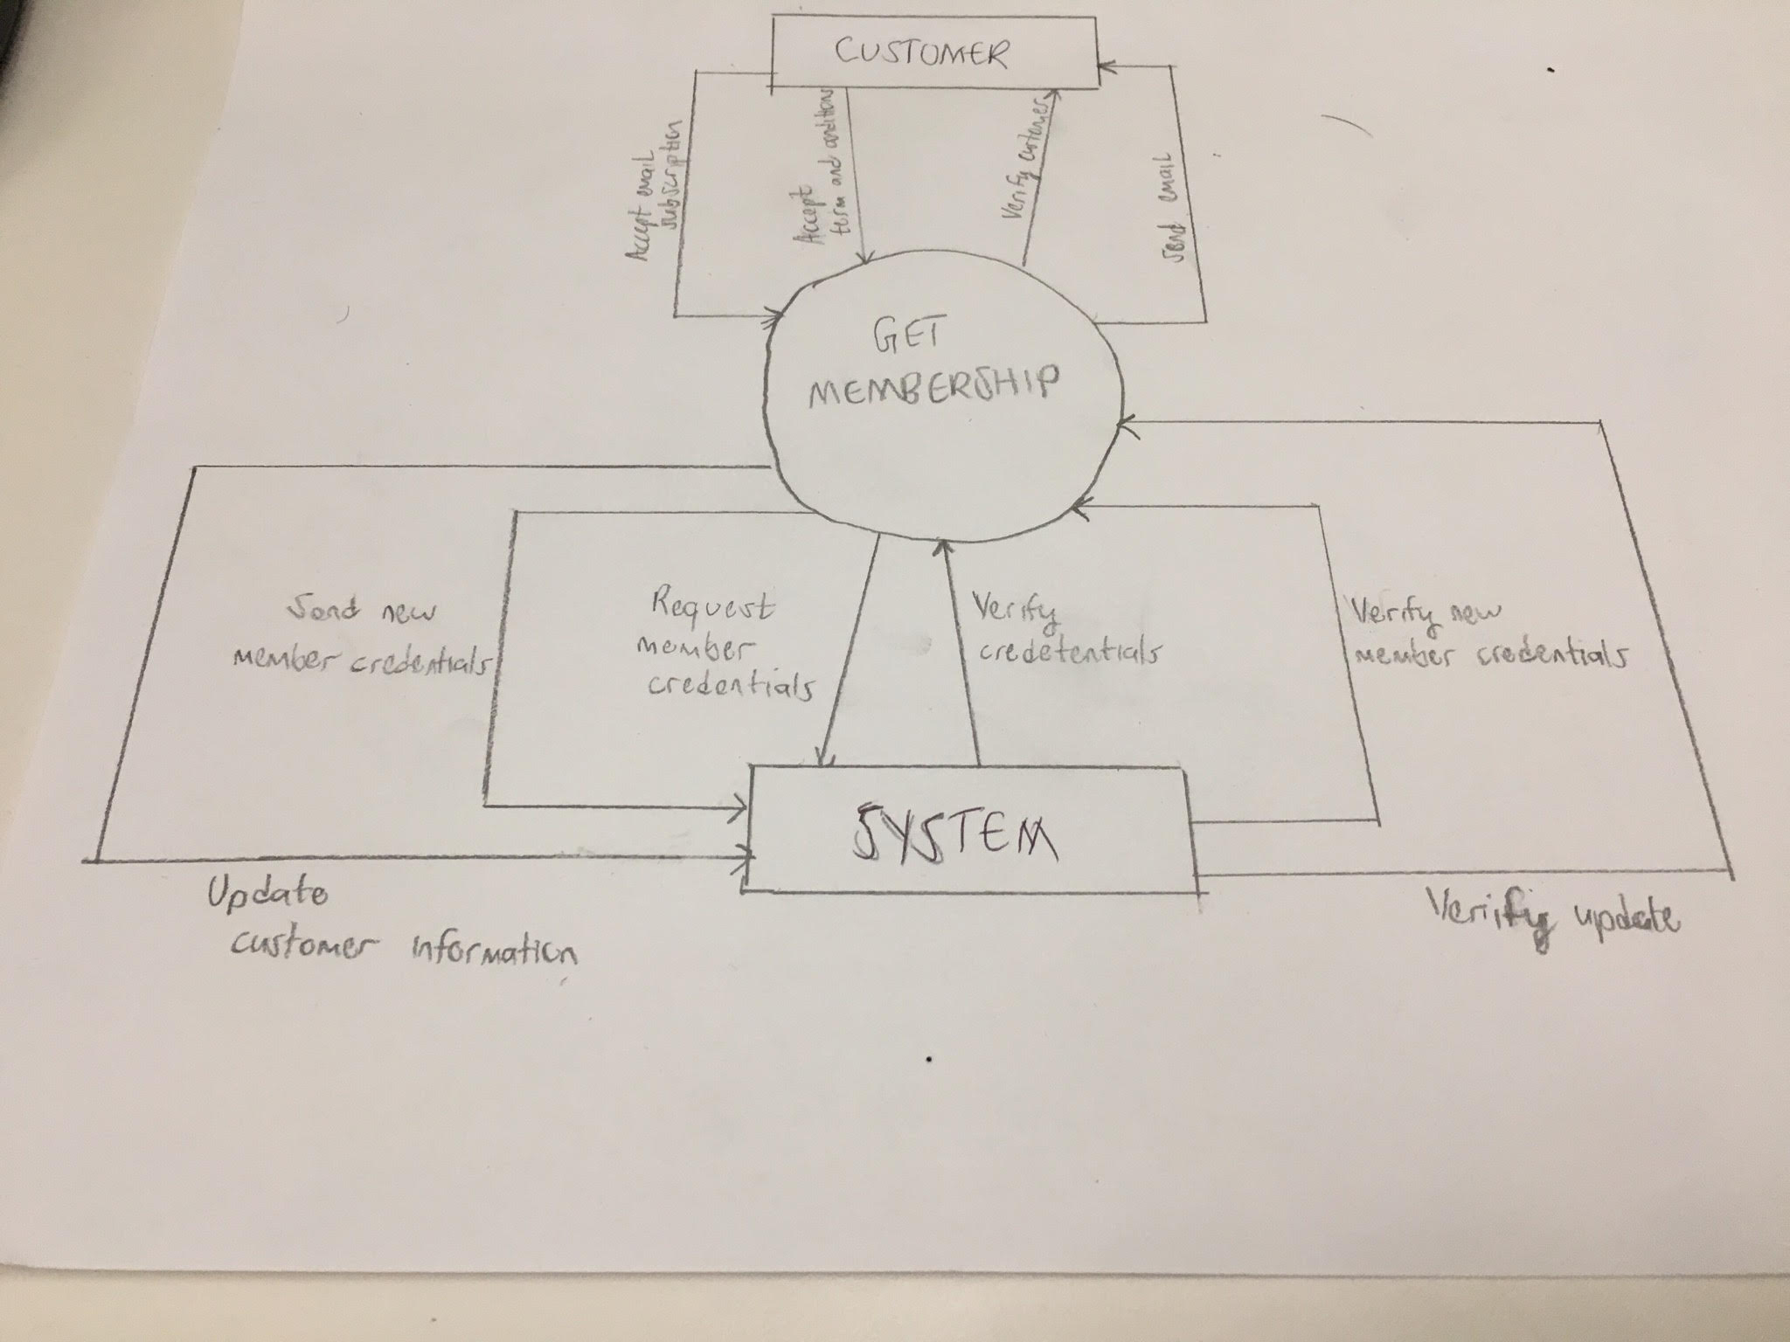

## **Business Process** 8**:** Provide recommendations based on price and popularity **by** Luqman Dewji

### **To-Be Process**

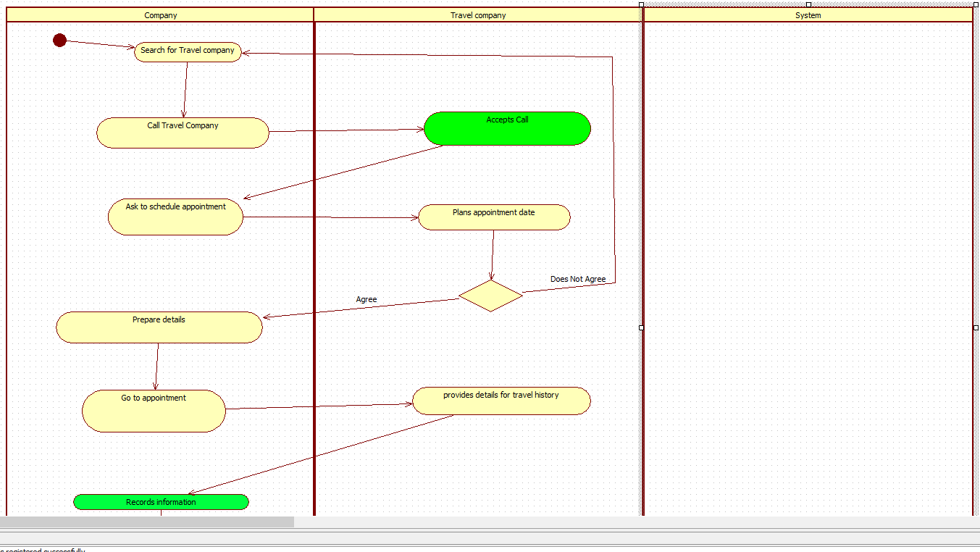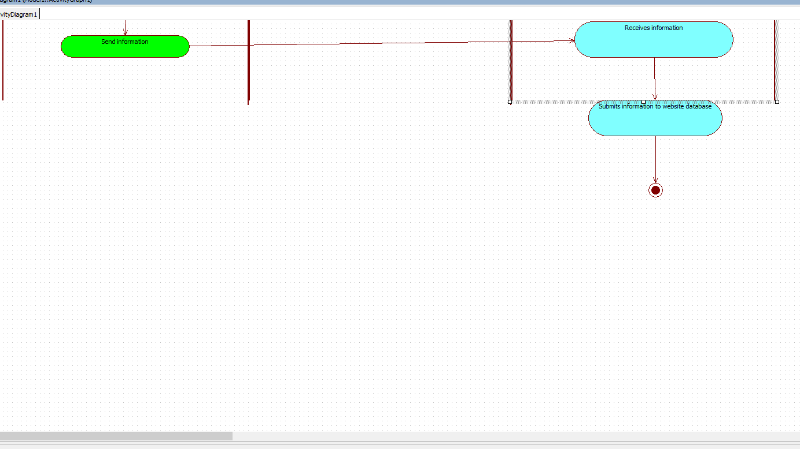

### **Context Diagram for To-Be Process**

In the context diagram for the to-be process, the circle is the to-be business process you are modeling.

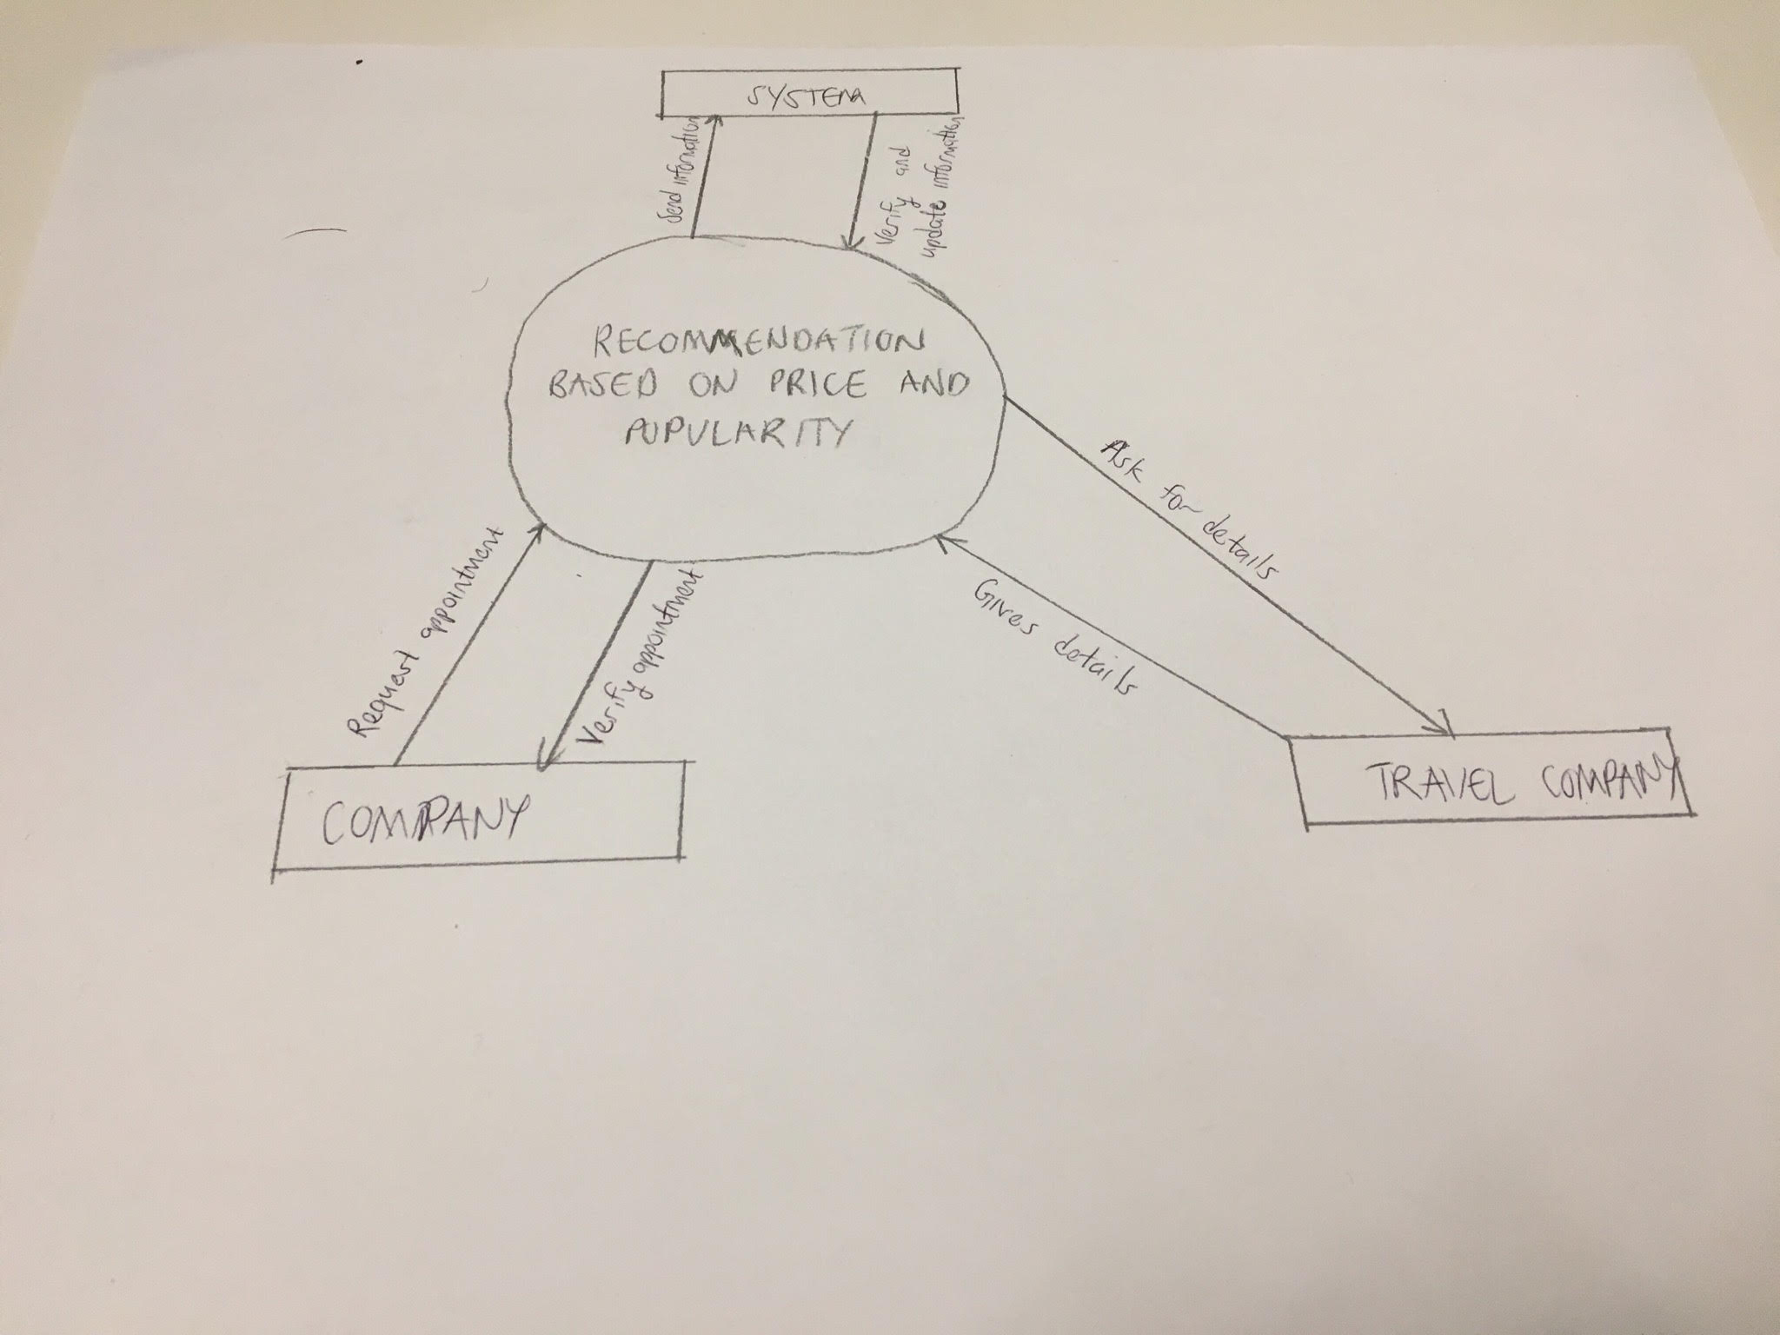

# **System Use Case Diagram(s)**

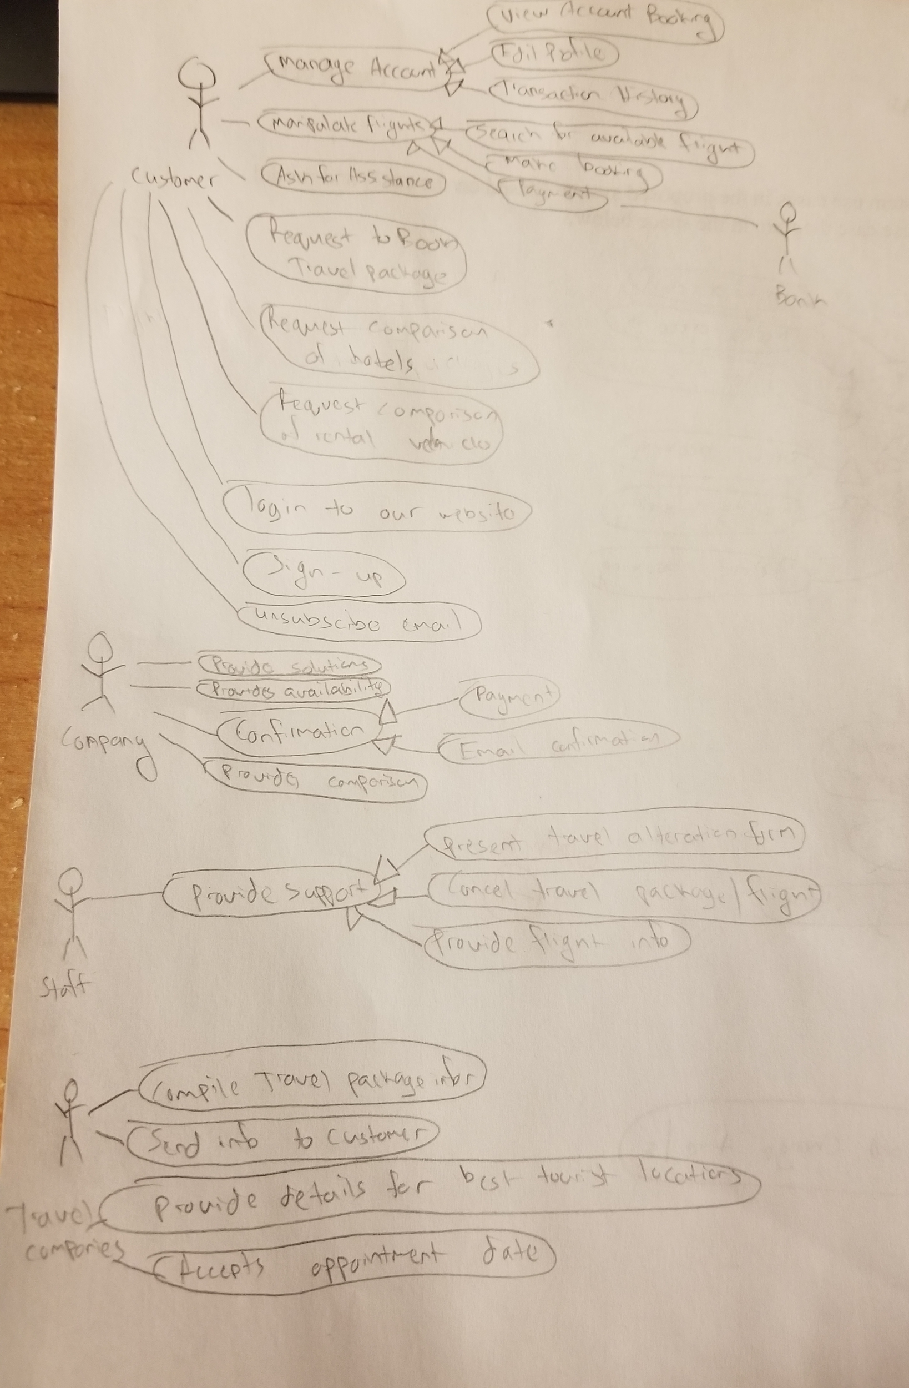

# **System Use Case Specifications**

## Search Flight on selected dates

### **Author:** Khai Phan

### **Short Description of the System Use Case**

* Allow customer to book a flight that meets their requirement and satisfaction. System Database will provide customers with the cheapest flight possible

### **Actor(s)**

* Customers
* Credit Cards company
* System Database
* Our Company (Flight Service department)

### **System Use Case Preconditions**

* Customer needs to purchase the flight

### **System Use Case Successful Post Conditions**

* Customers can book a flight going to their favorite destination with the closest date desired

### **Applicable Business Rules**

* No Business Rules is required

### **Main Flow:**

|  |  |  |
| --- | --- | --- |
|  | **Actor (Customer)** | **System** |
| 1 | Select flight destination, dates | Validating information, check system database |
| 2 | Select between options for flight dates and airlines | Validate selected flight (*1). Credit Card required |
| 3 | Enter Credit Card information | Validate credit card (*2). Displaying successful payment |
| 4 | (Company) Check for payment inquiry | Validate Payment received (*3) |
| 5 | (Company) Issue ticket and confirmation email | Send the information to the customer |

### **Alternate Flows**

|  |  |  |
| --- | --- | --- |
|  | Alternate Flow | Description |
| A1 | Flight no longer available | Show an error and prompt customer to select another flight |
| A2 | An issue with Credit Card | Displaying the error received from banking company and prompt customer to use different Credit Card for payment |
| A3 | Error in the system handling | Call customers or send an email about money problem. The System sometimes receive problem but still consider the transaction as successful |

### **System Use Case Activity Diagram**

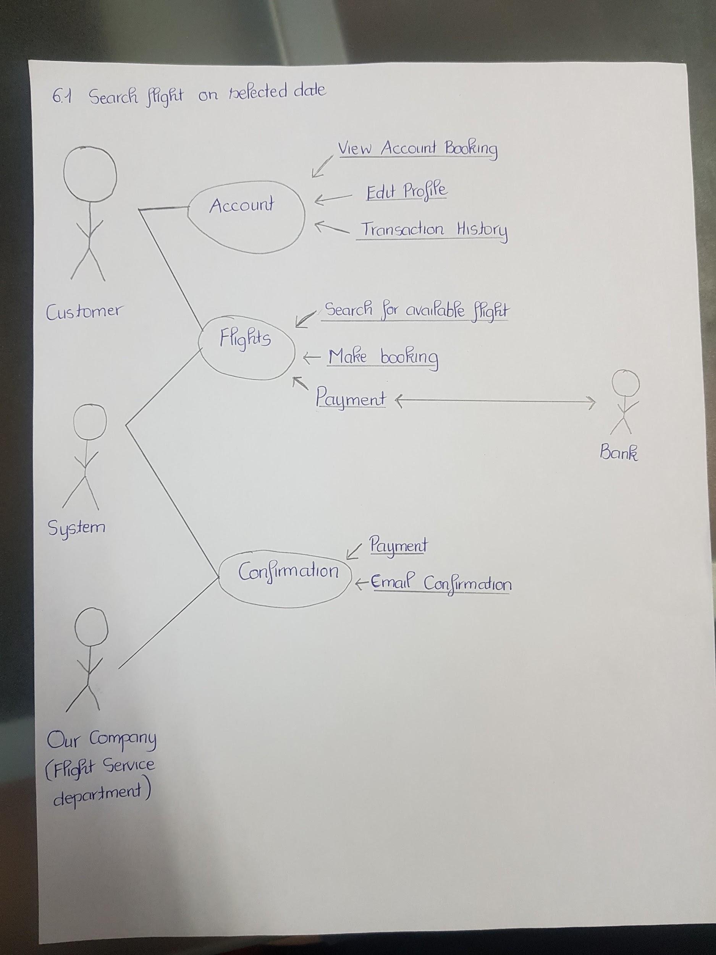

### SSD Diagram

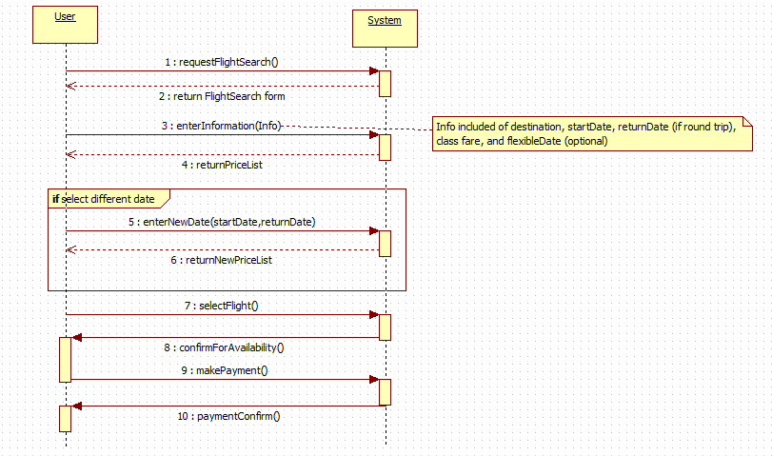

## Make changes to Flight ticket

### Author: Khai Phan

### Short Description of the System Use Case

* Customers can make changes such as dates, times, flight seat and meals, or return the ticket)

### Actor(s)

* Customer
* Credit Card company
* System Database
* Our Company (Flight Service department)

### System Use Case Preconditions

* Purchased a flight from our site
* Change(s) must make 24 hours before departure time
* Flight date is not passed

### System Use Case Successful Post Conditions

* Change(s) was successfully made

### Applicable Business Rules

* No Business Rules is required

### Main Flow:

|  |  |  |
| --- | --- | --- |
|  | Customer | System |
| 1 | Enter booking reference | Validate booking reference(*1), check for flight conditions |
| 2 | Select the desired change | Check if changes if the change is available(*2), proceed customer verify change(*3) |
| 3 | Confirm new change | Proceed to the company for verification |
| 4 | (Company) (If) Check for payment received | Validate Payment received(*4) |
| 5 | (Company) Issue ticket and new confirmation email | Send the information to the customer |

### Alternate Flows

|  |  |  |
| --- | --- | --- |
|  | Alternate Flow | Description |
| A1 | Booking Reference Failed | If unable to validate booking reference, required the customer to enter a new one |
| A2 | Change is available | If change is not available from our side, we will display an error and direct customer to the airline's website where the change may be possible. |
| A3 | Verify change | If the change is free, the customer will be required to confirm if they still want to do the change. If there is a fee, the customer will need to confirm if they still want to proceed and they can choose to pay using the previous card or different card |
| A4 | Error in the system handling | Call customers or send an email about money problem. The System sometimes receive problem but still consider the transaction as successful |

### System Use Case Activity Diagram

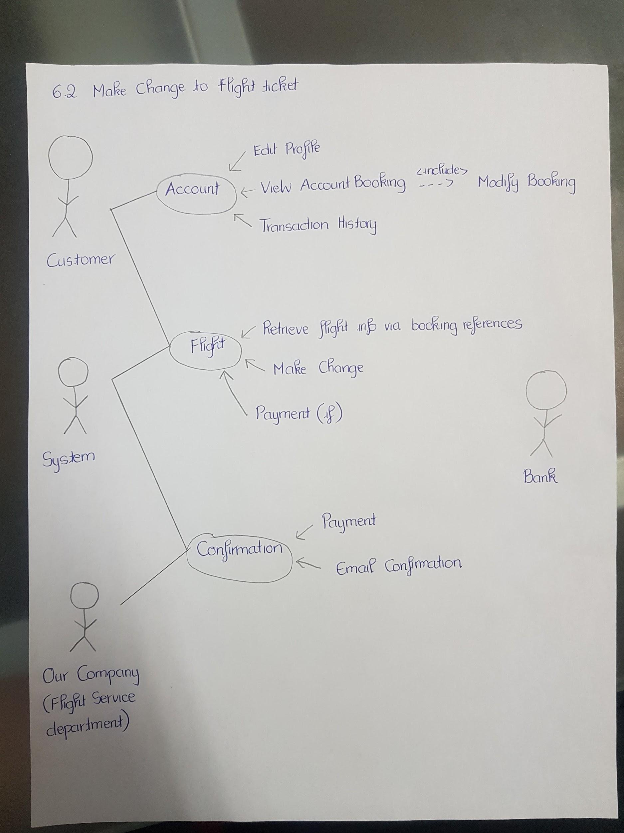

### SSD Diagram

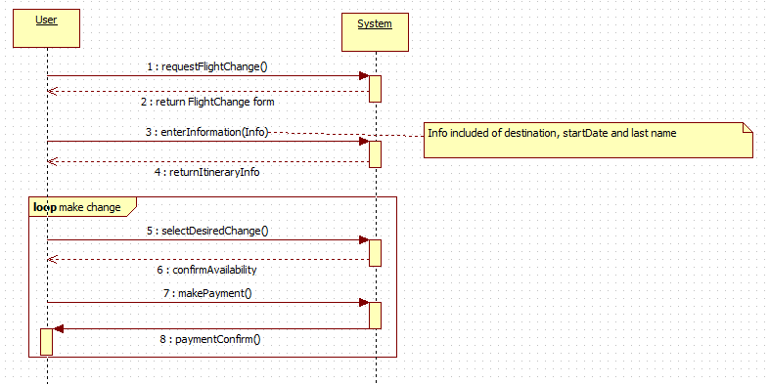

## Contact Customer Support

### Author: Zain Ali

### Short Description of the System Use Case

The customer can request help from the website, and the system will support the staff in providing help

### Actor(s)

* Customer
* Staff

### System Use Case Preconditions

A staff member must always be available, incase a customer requires help

### System Use Case Successful Post Conditions

* The customer receives the necessary help he/she requires about travel/vacation packages

### Applicable Business Rules

* Support must always be given through a staff member

### Main Flow:

|  |  |  |
| --- | --- | --- |
|  | Customer | System |
| 1 | Clicks on Assistance | Provides Help Options |
| 2 | Select Help Option | Assigns Staff Member to Help |
| 3 | Selects Help Option from staff provided options | Provide Support |

### Alternate Flows

|  |  |  |
| --- | --- | --- |
|  | Alternate Flow | Description |
| A1 | choice made other than help option | System redirects user to corresponding choice |
| A2 | User can click on assistance | Provides Help Options |
| A3 |  |  |

### System Use Case Activity Diagram

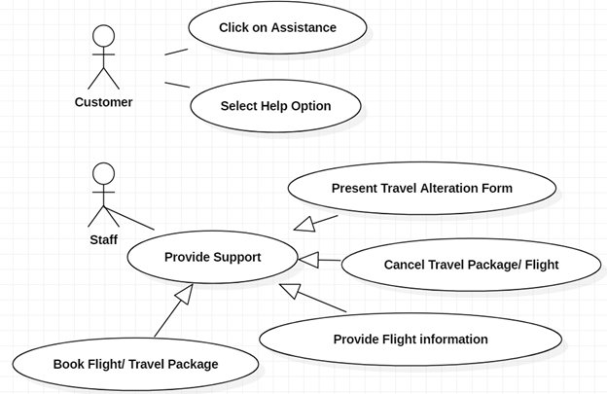

### SSD Diagram

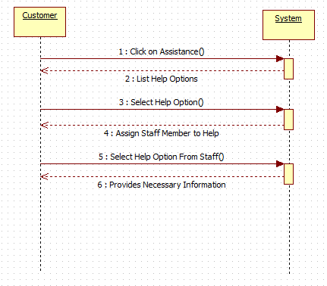

## Select Popular Vacation Packages

### Author: Zain Ali

### Short Description of the System Use Case

The customer inputs desired dates for travel and the system compiles a list of the travel packages available with the help of travel companies.

### Actor(s)

* Customer
* Travel Companies

### System Use Case Preconditions

Accurate Dates must be input

### System Use Case Successful Post Conditions

* Customer is presented with travel packages according to the input date

### Applicable Business Rules

* No business rules required

### Main Flow:

|  |  |  |
| --- | --- | --- |
|  | Customer | System |
| 1 | Requests to Book travel package | Prompts Customer to input desired dates |
| 2 | Inputs Dates | Compiles Travel Packages and sends to customer |
| 3 | Makes Decision on Travel Package |  |

### Alternate Flows

|  |  |  |
| --- | --- | --- |
|  | Alternate Flow | Description |
| A1 | Dates entered have no availability | System Prompts to enter different dates |
| A2 | Customer enters different dates | System loops in prompts until valid date entered |
| A3 |  |  |

### System Use Case Activity Diagram

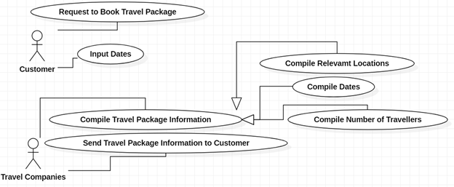

### SSD Diagram

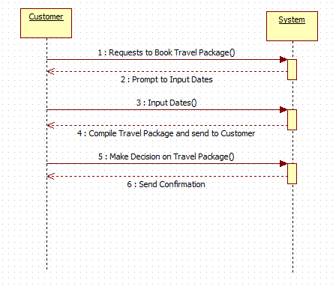

## Compare prices among different hotel services

### Author: Adrian Recchi

### Short Description of the System Use Case

Users are able to browse and choose from a list of available hotels to best suit their needs.

### Actor(s)

* Customer
* Our Company
* Hotel Company

### System Use Case Preconditions

Customer must be able to access the website (have internet connection)

### System Use Case Successful Post Conditions

* The best possible hotel choice is provided to the customer

### Applicable Business Rules

* Customer should be able to navigate search results with ease

### Main Flow:

|  |  |  |
| --- | --- | --- |
|  | Customer | System |
| 1 | Requests potential hotel options | Provides a list of hotels |
| 2 | Requests a particular hotel | Specified hotel is available |
| 3 | Requests a comparison | Provides a similar option for comparison |
| 4 | Decides on a hotel |  |

### Alternate Flows

|  |  |  |
| --- | --- | --- |
|  | Customer | Description |
| A1 | Requests potential hotel options | Provides a list of hotels |
| A2 | Requests a particular hotel | Specified hotel is NOT available |
| A3 | Requests a different option for availability | Process repeats unless chosen hotel IS available |

### System Use Case Activity Diagram

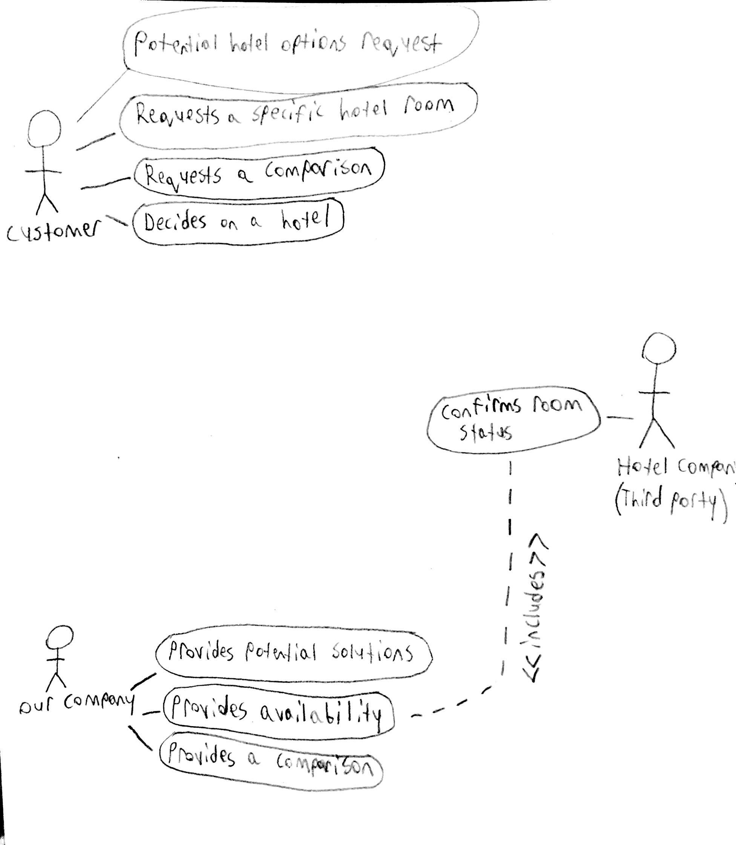

### SSD Diagram

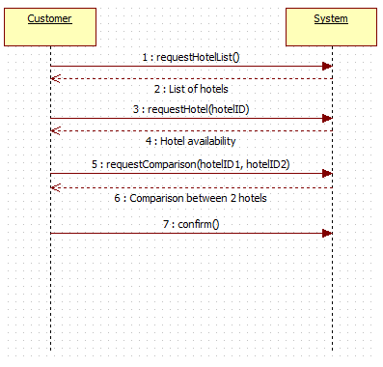

## Compare different prices between rental vehicles

### Author: Adrian Recchi

### Short Description of the System Use Case

Users are able to browse and choose from a list of available vehicles that best suit their intended purposes.

### Actor(s)

* Customer
* Our Company
* Vehicle Company

### System Use Case Preconditions

Customer must be able to access the website (have an internet connection)

### System Use Case Successful Post Conditions

* The best possible rental vehicle option is provided to the customer

### Applicable Business Rules

* The customer should be able to navigate search results with ease

### Main Flow:

|  |  |  |
| --- | --- | --- |
|  | Name of actor(s) | System |
| 1 | Requests potential vehicle options | Provides a list of vehicles |
| 2 | Requests a particular vehicle | Specified vehicle is available |
| 3 | Requests a comparison | Provides a similar option for comparison |
| 4 | Decides on a vehicle |  |

### Alternate Flows

|  |  |  |
| --- | --- | --- |
|  | Alternate Flow | Description |
| A1 | Requests potential vehicle options | Provides a list of vehicles |
| A2 | Requests a particular vehicle | Specified vehicle is NOT available |
| A3 | Requests a different option for availability | Process repeats unless chosen vehicle IS available |

### System Use Case Activity Diagram

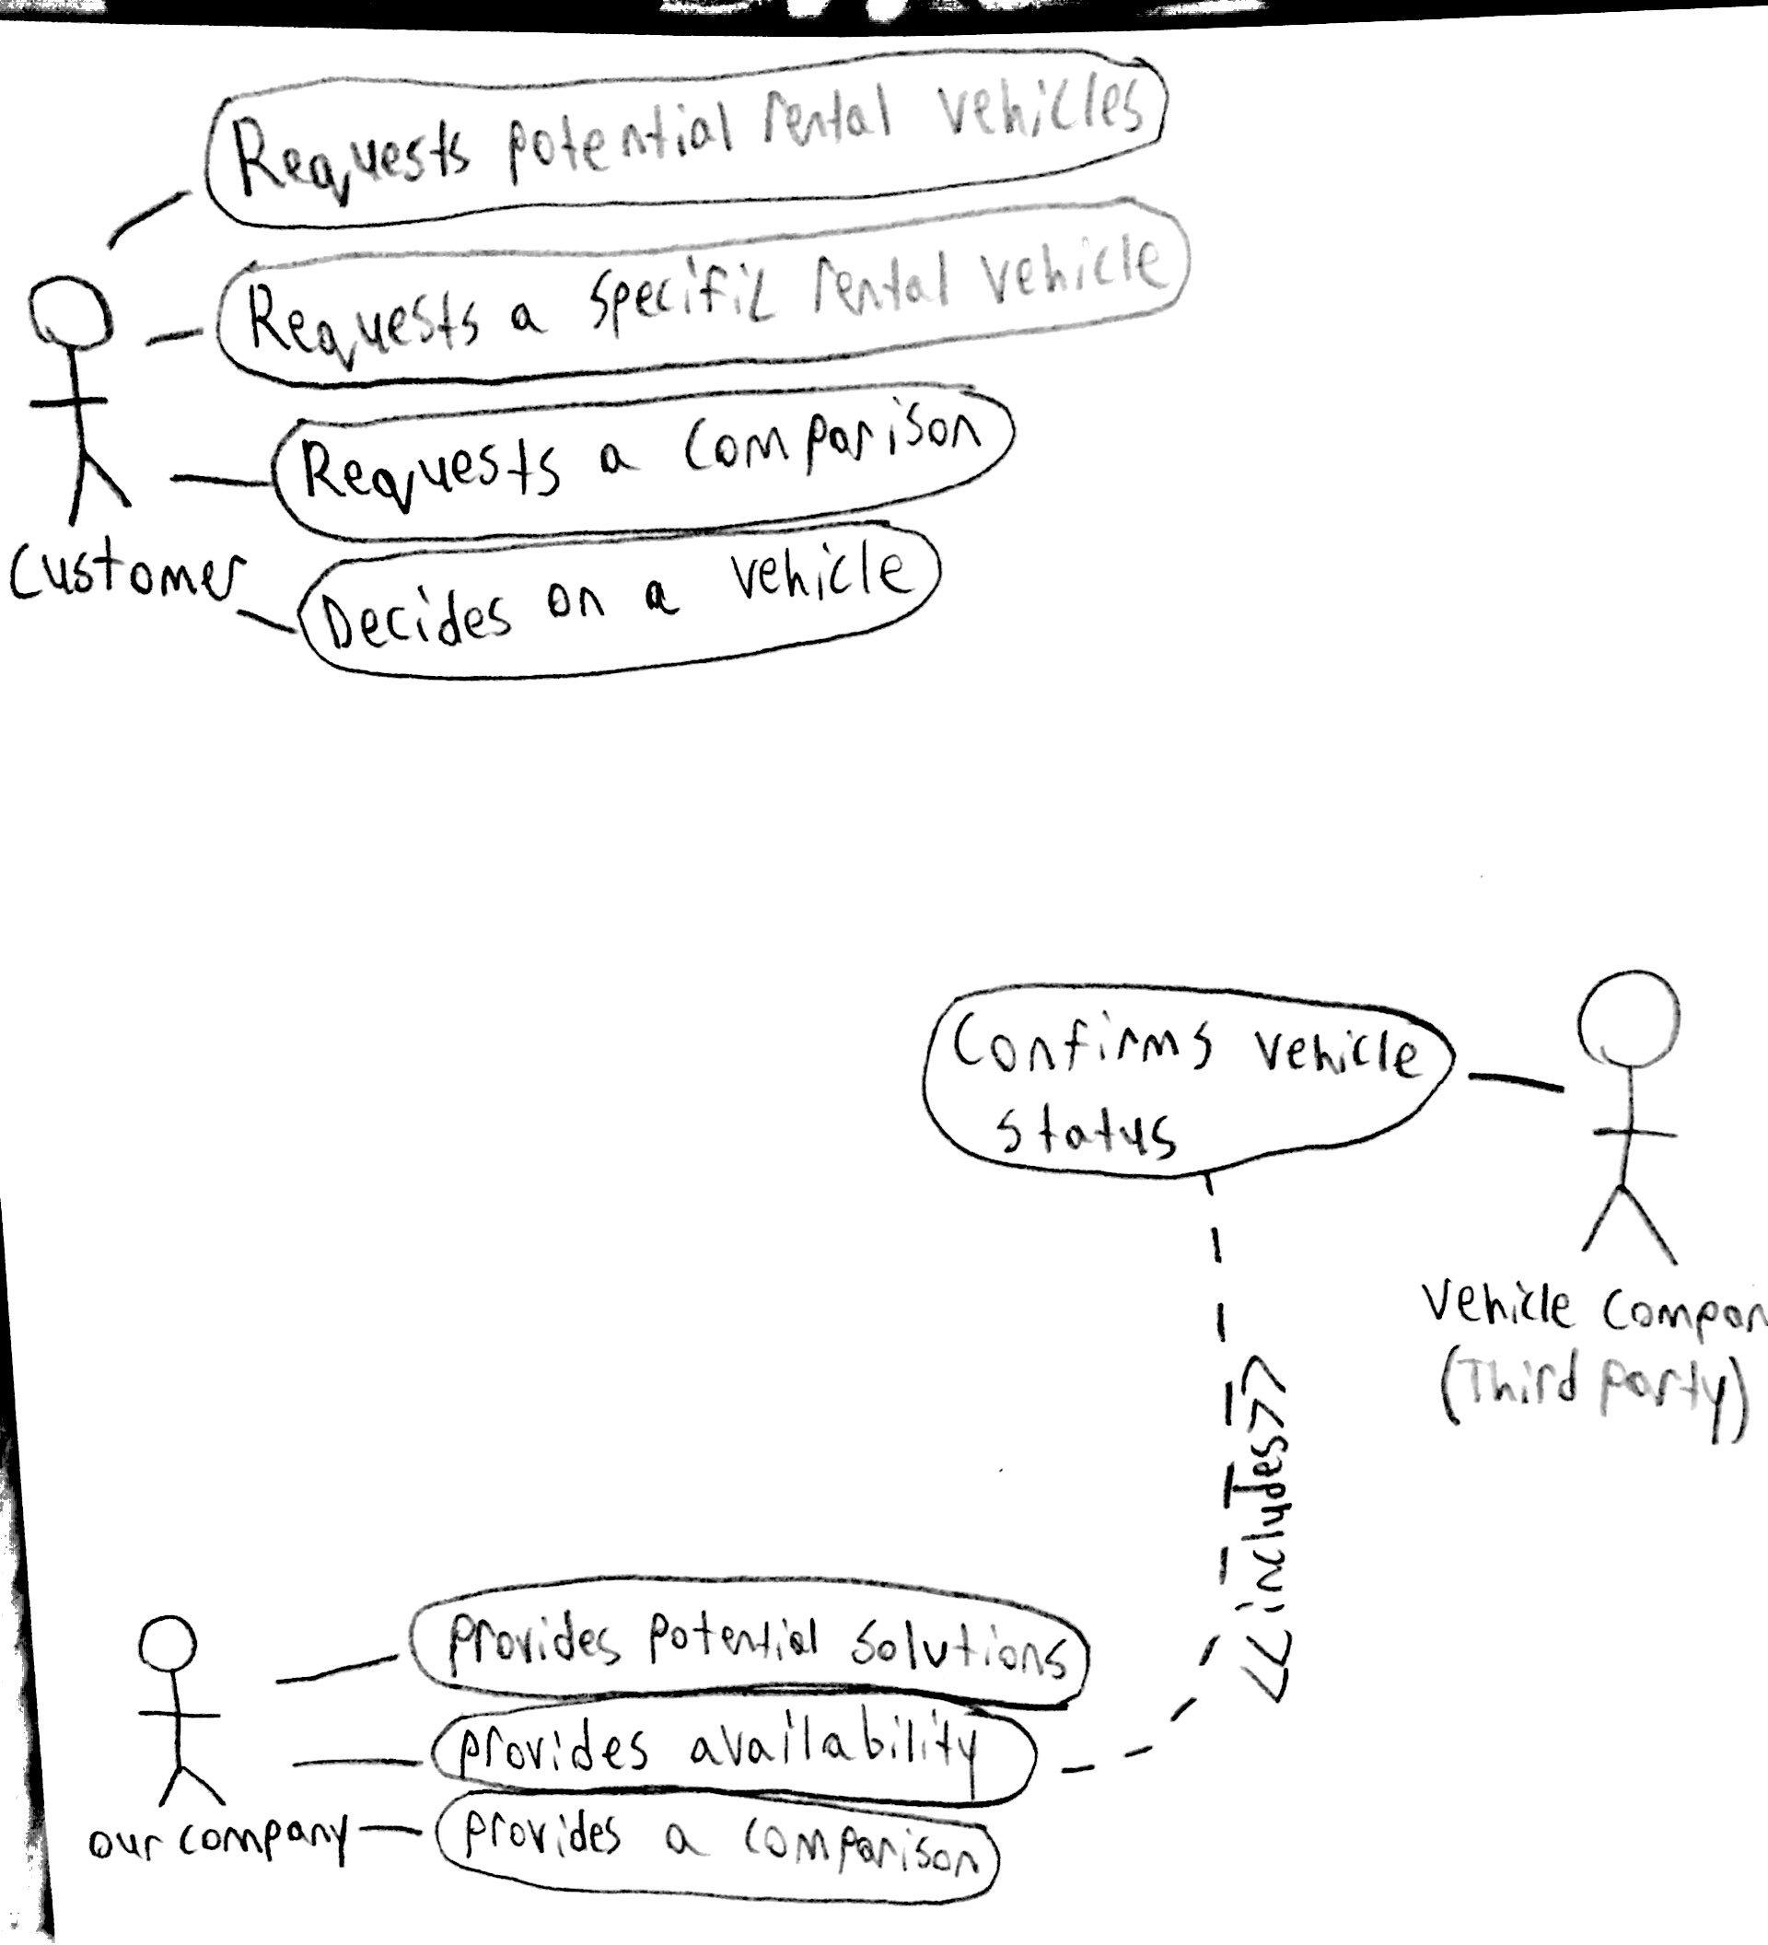

### SSD Diagram

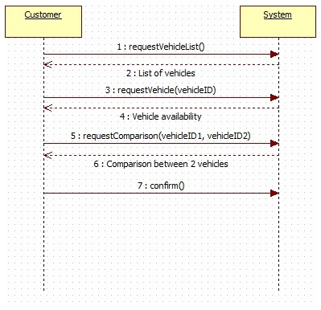

## System Use Case Name: Sign up for membership

### Author: Luqman Dewji

### Short Description of the System Use Case

The customers are able to join in our newsletter and offers by becoming a member.

### Actor(s)

* Customer (Secondary)
* System (Primary)

### System Use Case Preconditions

Customer must have access to the internet.

Customer must have an email account.

### System Use Case Successful Post Conditions

* The best offers and newsletter is emailed daily to the customer.

### Applicable Business Rules

* The customer can sign up easily.

### Main Flow:

|  |  |  |
| --- | --- | --- |
|  | Name of actor(s) - **(Customer)** | System |
| 1 | Enters log-in details as a member | Validates and logs in the customer |
| 2 | Choose a sign-up option | Display page for sign up option |
| 3 | Choose to unsubscribe from email | Removes customer from subscription list |

### Alternate Flows

|  |  |  |
| --- | --- | --- |
|  | Alternate Flow | Description |
| A1 | Log in details failed | requires the customer to re-enter the login credentials |
| A2 | Does not agree to terms and conditions | requires the customers to accept the terms and conditions to proceed to further steps |
| A3 | End membership | asks to confirm the circumstance and removes the customer |

### System Use Case Activity Diagram

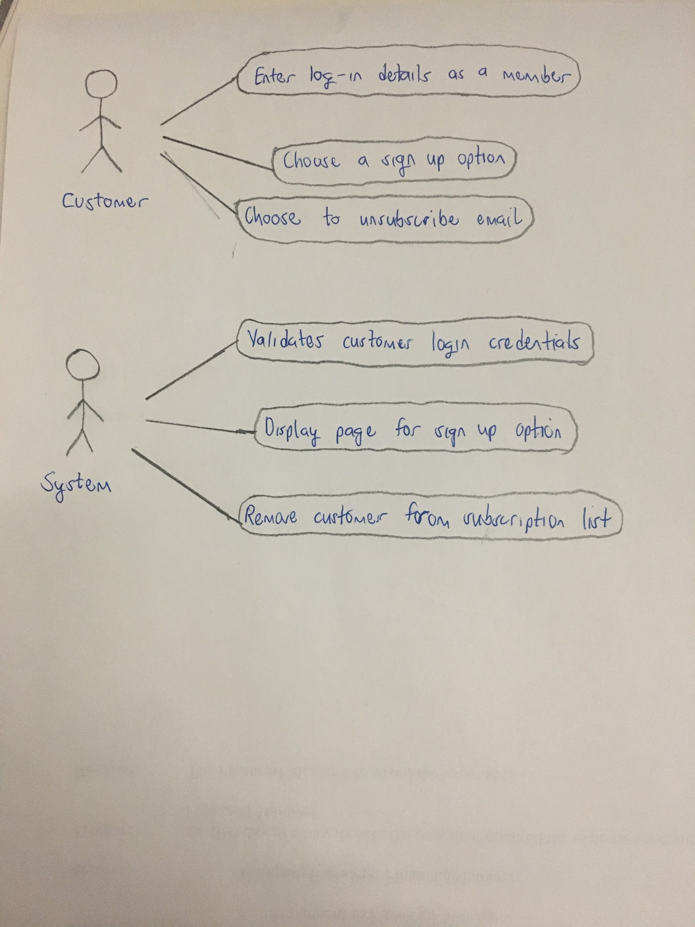

### SSD Diagram

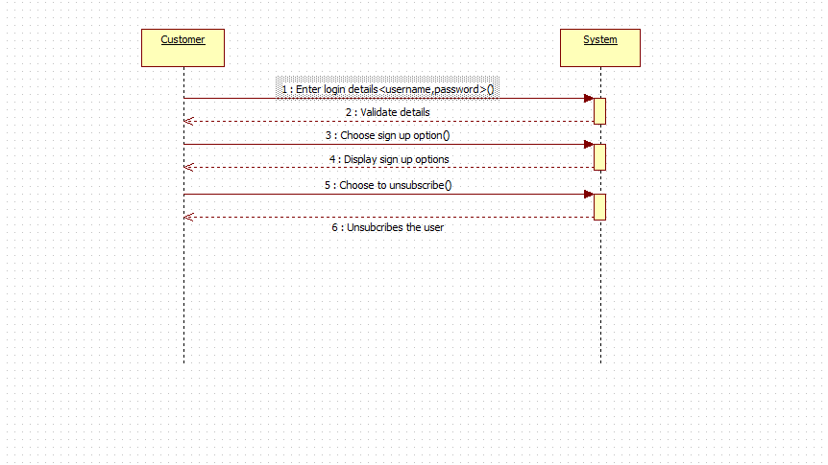

## System Use Case Name: Provide recommendations based on price and popularity

### Author: Luqman Dewji

### Short Description of the System Use Case

The system shows the best tourist locations to visit based on their price and popularity

### Actor(s)

* Company (Primary)
* Travel company (Secondary)
* System (Secondary)

### System Use Case Preconditions

Must have access to the internet

Must have transport

Must have programming knowledge to update the website

### System Use Case Successful Post Conditions

* Best tourist locations are posted on our company’s website

### Applicable Business Rules

* The company provides best-detailed information for tourist locations

### Main Flow:

|  |  |  |
| --- | --- | --- |
|  | Name of actor(s) - **(Company)** | System |
| 1 | Send details for tourist locations | Updates and post in the company’s website |
| 2 | Searches for the best travel company | Retrieves and output the information |
| 3 | Record appointment date for the reminder | reminds the company for the appointment date. |

### Alternate Flows

|  |  |  |
| --- | --- | --- |
|  | Alternate Flow | Description |
| A1 | Same details for tourist location recorded more than once in the system | Shows error and suggests to change and enter a new detail for a tourist location. |
| A2 | Does not update the website daily | Suggests to update the website |
| A3 | Does not code the website sufficiently | Shows error and asks to re-compile the program for the website. |

### 6.8.7 System Use Case Activity Diagram

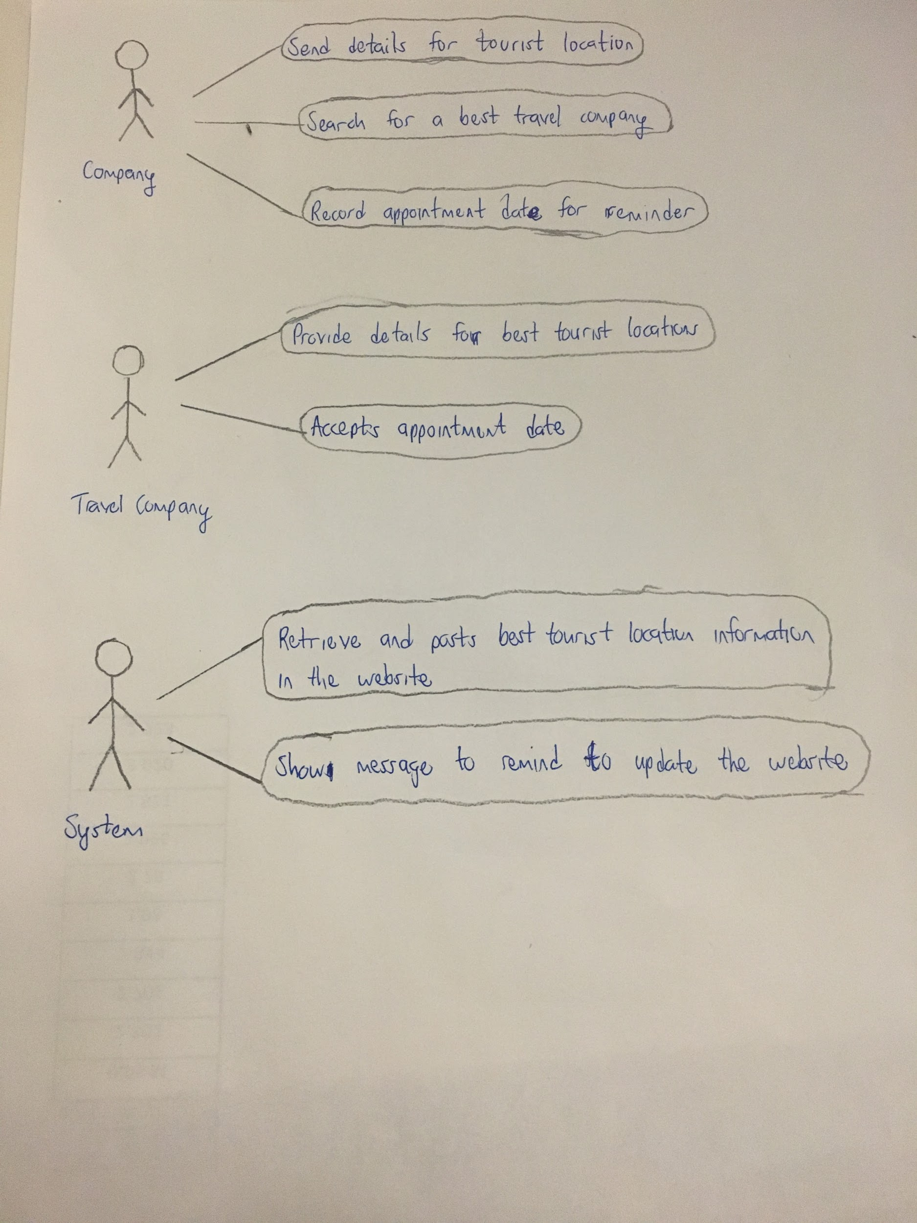

### SSD Diagram

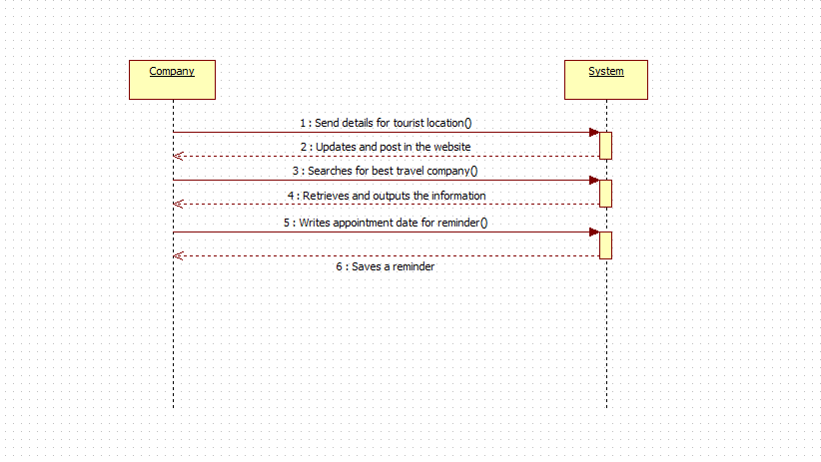

# **Non-Functional requirements**

In the table below you are asked to specify the type of non-functional requirement you have identified and then describe what the requirement is and how you plan to satisfy it.

|  |  |  |
| --- | --- | --- |
|  | **Requirement Type** | **Description and Implementation Plan** |
| **1.** | Functionality | This business system satisfied most of the user’s requirement in term of deals, price-matching, and accuracy. However, we do not guarantee this included all data system such as airlines or hotels. |
| **2.** | Performance Efficiency | Right now, the system only able to handle 10 transactions per minutes due to security reason. We are looking for a solution to allow users a faster payment method. |
| **3.** | Localization | Our business model only available in English at the moment so it's a restriction to some person |